# 

# EE464 Static Power Conversion II

# Term Project Final Report

## Hiper-Optik Basküler Converter

## Ömer ŞEN – 2305415

## İsmail MACİT –

## Yasin Enes ÇALIŞKAN –

## Introduction

In this project, an isolated DC-DC converter will be designed and implemented. Required converter will have 12-18V input voltage range and 48V output voltage. Output voltage will have at most 3% voltage ripple and output power rating will be 48W. Deviation of percent output voltage when input voltage is changed from its minimum to maximum will be at most 3%. Deviation of percent output voltage when load current is changed from 10% to 100% will be at most 3%. Push

## Component Selection

|  |  |  |
| --- | --- | --- |
| **Component** | **Quantity** | **Price** |
| LM5030 | 1 | 2.81$ |
| LTV-816W | 1 | 0.11$ |
| TL431ACZ | 1 | 0.135$ |
| IRF540N | 2 | 1.66$ |
| MBR20200 | 1 | 0.59$ |
| Custom Transformer(00K6527E060x2) | 1 | 20$ |
| Custom Inductor(55928A2) | 1 | 8-10$ |
| SF34 (Schottky) | 2 | 0.24$ |
|  |  |  |
|  |  |  |
|  |  |  |
|  |  |  |
|  |  |  |
|  |  |  |

### LM5030 100-V Push-Pull Current Mode PWM Controller

LM5030 controller is chosen as controller since it is push-pull controller, it has voltage and current feedback, which will provide much accurate control and controller bonuses. Even if its lower limit of the controller, input voltage is appropriate for the application.

## LTV816

This component is selected because it was readily available at the laboratory, and there were not any sharp limits about the optocoupler so it is used for isolated feedback design in the type-II compensator.

### TLC431ACZ

This component is used to bias the feedback such that we can get a reference from the output by a voltage division using two resistors.

#### **IRF540N**

This component is selected because it was readily available at the laboratory. However, the switching losses were high compared to conduction losses. Anyway, it is used and tested in the design.

**MBR20200**

This component is selected because it is a Schottky diode so it has very low losses. Moreover, our design required a voltage of around at least 168V. This was a cheap and available component that is used.

**SF34**

This component is used as a replacement of the MBR20200, when we didn’t have stock for MBR20200.

## Design Decision

Since one of the most important requirements is isolation, applicable topologies are limited. At that point, based on the industrial experience, it is advised that the most important component is the controller for the application. Therefore, the topology must be built around the controller. Through the market research, Flyback and Push-Pull controllers are found. Hiper-Optik Basküler Converter chose Push-Pull topology to be implemented. Some of the reasons to choose Push-Pull converter are following

* Reduced voltage stress: In a push-pull converter, the primary winding of the transformer operates in a center-tapped configuration, allowing for symmetrical voltage waveforms. This results in reduced voltage stress on the primary side components compared to a flyback converter.
* Higher efficiency: Push-pull converters typically exhibit higher efficiency compared to flyback converters. The symmetrical operation of the push-pull configuration helps to minimize power losses and improve overall converter efficiency.
* Lower output ripple: The push-pull converter's center-tapped transformer configuration and its ability to operate in a continuous current mode result in lower output voltage ripple compared to a flyback converter. This can be beneficial for applications requiring lower output voltage ripple.
* Utilizing 2 switches: It is decided that for both of the converter topologies, 2 switches implementation should be done. At that point, it is stated that “if two switches will be controlled, then it should be push-pull”.

Next, turns ratio is supposed to be chosen. Based on the Push-Pull input output relationship, duty cycle limits, input voltage range and output voltage, N2/N1 is decided as 40/9 and duty cycle is set as 0.3<D<0.45, to not operate at upper limits and to not increase burden of output capacitor.



Based on the duty cycle and Vin-Vout relation, Nseconday/Nprimary=40/9 is chosen.









Therefore, duty cycle range is found as



Based on the frequency range of the controller, 100kHz switching frequency is decided. After, some working conditions are set, such as magnetic field is set as 0.2T, current density is set as 4A/mm2. Based on the output voltage, switching frequency, magnetic field and current density, Core-Window area is decided. After, a core is chosen and according to its dimensions, numbers of primary and secondary windings are calculated. Then, primary referred Lm is calculated by using number of turns and core specifications. Based on the max expected current to be flown and, required cable cross sectional area is calculated. Then, due to skin effect, appropriate awg cable is decided and required numbers of parallel cables are calculated. Finally, kcu is calculated to observe whether the design is under-design or over-design or proper.





$$B_{max}=0.02T\left(reason explained later\right) J=4\frac{A}{mm^{2}} D_{cma}=715 circ. mils/A$$

Then,  is calculated as

$$W_{a}*A_{c}=\frac{P_{o}*D_{cma}}{K_{t}*B_{max}*f}=\frac{48W*\left(\frac{1}{4\frac{A}{mm^{2}}*0.00035}\right)\frac{circular mils}{A}}{0.001*200Gauss*100kHz}=1.74{cm}^{4}$$

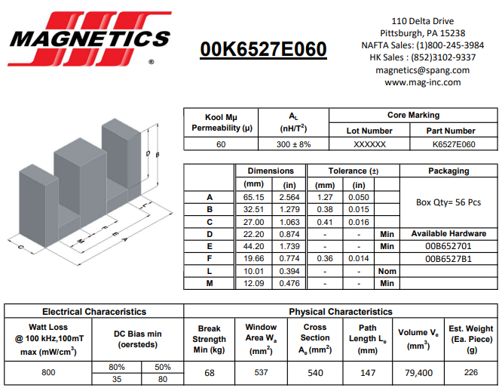

Figure 1: Chosen Core Specifications

$$W_{a}=5.37cm^{2} A_{c}=5.4cm^{2} A_{L}=300\frac{nH}{Turn^{2}}$$

$$N_{primary}=\frac{V_{primary}*{10}^{8}}{4*B*A_{c}*f}=\frac{12V*{10}^{8}}{4*2000 Gauss*5.37cm^{2}*100kHz}=2.79 Turns≅3 Turns$$

$$N_{secondary}=N_{primary}*\frac{40}{9}=13.33 Turns≅13 Turns$$

$$L_{m}={\left(\frac{N_{primary}}{{10}^{3}}\right)}^{2}*A_{L}=2.7mH$$

$$I_{secondary,rms}=\sqrt{D*I_{o}^{2}+2*D*{\left(\frac{I_{o}}{2}\right)}^{2}}=\sqrt{0.45*1^{2}+2*0.45*{\left(\frac{1}{2}\right)}^{2}}=0.82A$$

$$I_{primary,rms}=\sqrt{0.45×I_{pri, average}^{2}}=2.68A$$

$$J=\frac{I}{A_{cable}} ⇒ 4\frac{A}{mm^{2}}=\frac{0.82A}{A_{sec}} ⇒ A_{sec}=0.21mm^{2} at least$$

$$J=\frac{I}{A_{cable}} ⇒ 4\frac{A}{mm^{2}}=\frac{2.68A}{A_{pri}} ⇒ A_{pri}=0.67mm^{2} at least$$

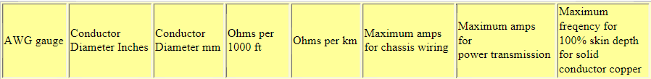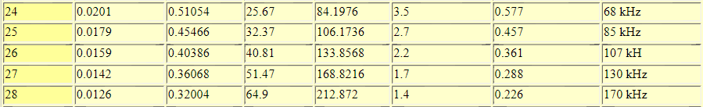

Figure 2: AWG Table

4x26AWG for secondary, which can operate with 100% skin depth at 100kHz.

8x26AWG for primary, which can operate with 100% skin depth at 100kHz.

$$k_{cu}=\frac{2*A_{pri,cable}*N_{primary}+2*A_{sec,cable}*N_{secondary}}{W_{a}}=\frac{2*1.026mm^{2}*3 Turns+2*0.513mm^{2}*13 Turns}{537{mm}^{2}}=0.036$$

0.036 fill factor shows that the core is over design for the required specs and application. Initially, more reasonable core with 0.34 fill factor was used, which is stated and show in Homework2 report. However, it was suspected during practice and testing that it might go into saturation, which was later found to be not the case. To be sure that the core does not go into saturation region; maximum B field is decreased to 1/10 of initial design, which is the reason of 0.02T max B field. As a result, dimensions of the required core were got bigger and fill factor decreased significantly. It is also believed that initial core is also works perfectly.

During the test it is observed that there is a great amount of power on the snubber circuits. In order to keep maintenance, high power resistances are used, which can withstand the power.

During the research, it is observed that usually type 2 error amplifier is utilized for the Push-Pull applications. Also, it has been observed that type 2 error amplifier is utilized with LM5030 controller.

## Topology

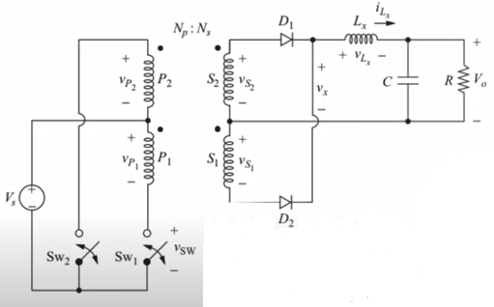

Figure 3: Push-Pull Converter Topology

Figure 4: First Sheet of Topology

Figure 5: Second Sheet of Topology

Push-pull converter is a type of DC-DC converter that uses a center-tapped transformer to convert a DC input voltage into a regulated DC output voltage. It is commonly used in power electronics applications where galvanic isolation and voltage conversion are required.

The basic operation of a push-pull converter involves the following stages:

1. Input Stage: The input stage consists of two switches, typically transistors, connected in a push-pull configuration. These switches alternate between conducting and non-conducting states based on a switching signal. When one switch is on, the other is off.
2. Transformer: The center-tapped transformer is connected to the switches in the input stage. The primary winding of the transformer is split into two halves, and the center tap is connected to the DC input voltage. As the switches alternate, the current flows alternately through the two halves of the primary winding.
3. Output Stage: The secondary winding of the transformer is connected to a rectifier (diodes) and filter circuit. Diodes prevent backward current flow from regulated DC output voltage into transformer.

The operation of the push-pull converter is based on the principle of transformer action and the switching of the input stage. When one switch is turned on, it allows the current to flow through one half of the primary winding, generating a magnetic field. When the switch is turned off, the magnetic field collapses, inducing a voltage in the secondary winding of the transformer. By properly controlling the switching signals of the input stage, the push-pull converter can regulate the output voltage. The duty cycle of the switches, which represents the ratio of the on-time to the total switching period, determines the output voltage level. By adjusting the duty cycle, the output voltage can be increased or decreased.

## Topology Implementation

## Simulation Results

## Test Results

## Conclusion